**Project 6 - Geometric Modeling**

Screenshot:

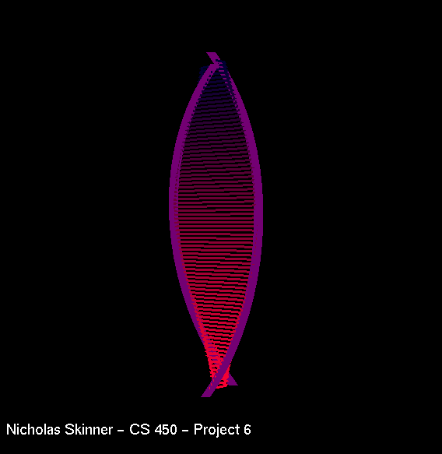

Video Link: <https://media.oregonstate.edu/media/t/1_max3km9e>

Thanks, and have a great day!